Greenland: A Secure Land Registration Scheme for Blockchain and AI-Enabled Agriculture Industry 5.0

In propose work author employing AI and Blockchain technologies in Land Registration as existing techniques were using centralized servers whose database can be easily tamper by server database administrator without getting detected. Blockchain has inbuilt support for decentralized storage, secured encrypted data storage and tamper proof data storage. In Blockchain based land registration ownership of registration will not be tamper any manner.

AI algorithms employed to detect fraud transaction from Blockchain Raw data which contains land details such as Sender information, receiver information, transaction type and many other raw data. AI algorithms will get trained on raw data and then trained model can be applied to detect frauds from future Blockchain raw data.

For accurate detection author has experimented with various ML algorithms such as Logistic Regression, Random Forest, SVM, XGBOOST and LIGHTGBM. Each algorithm performance was tuned using various hyper parameters and then evaluation done using various metrics such as Accuracy, Precision, Recall, FSCORE and ROC graph. Among all algorithms LIGHTGBM giving highest accuracy.

To train above algorithms author has used Ethereum dataset which can be download from below URL

https://www.kaggle.com/datasets/vagifa/ethereum-frauddetection-dataset/data

Land Transaction Raw data will get saved in IPFS (interplanetary file system) server whose storage hashcode will get saved in Blockchain for future retrieval. Blockchain can store or retrieve data using Smart Contracts which can be designed using Solidity Programming. This contract contains functions which can be called using any programming language to store and retrieve data. To manage Land transaction data we have designed following contract

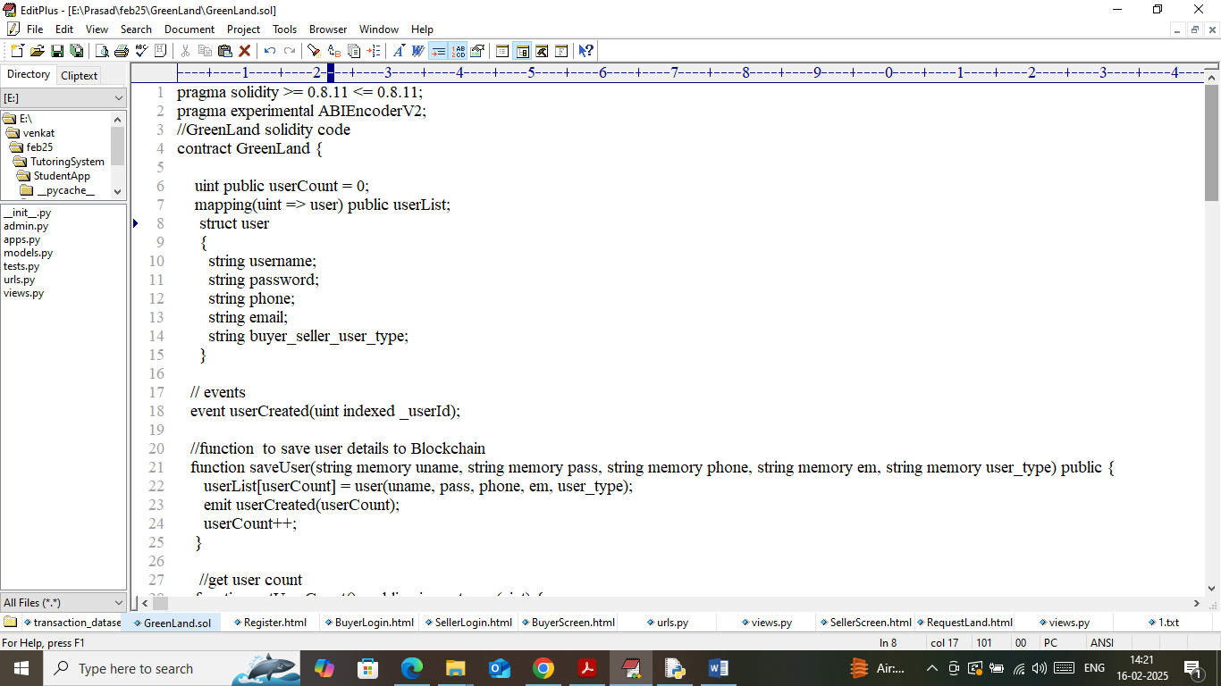

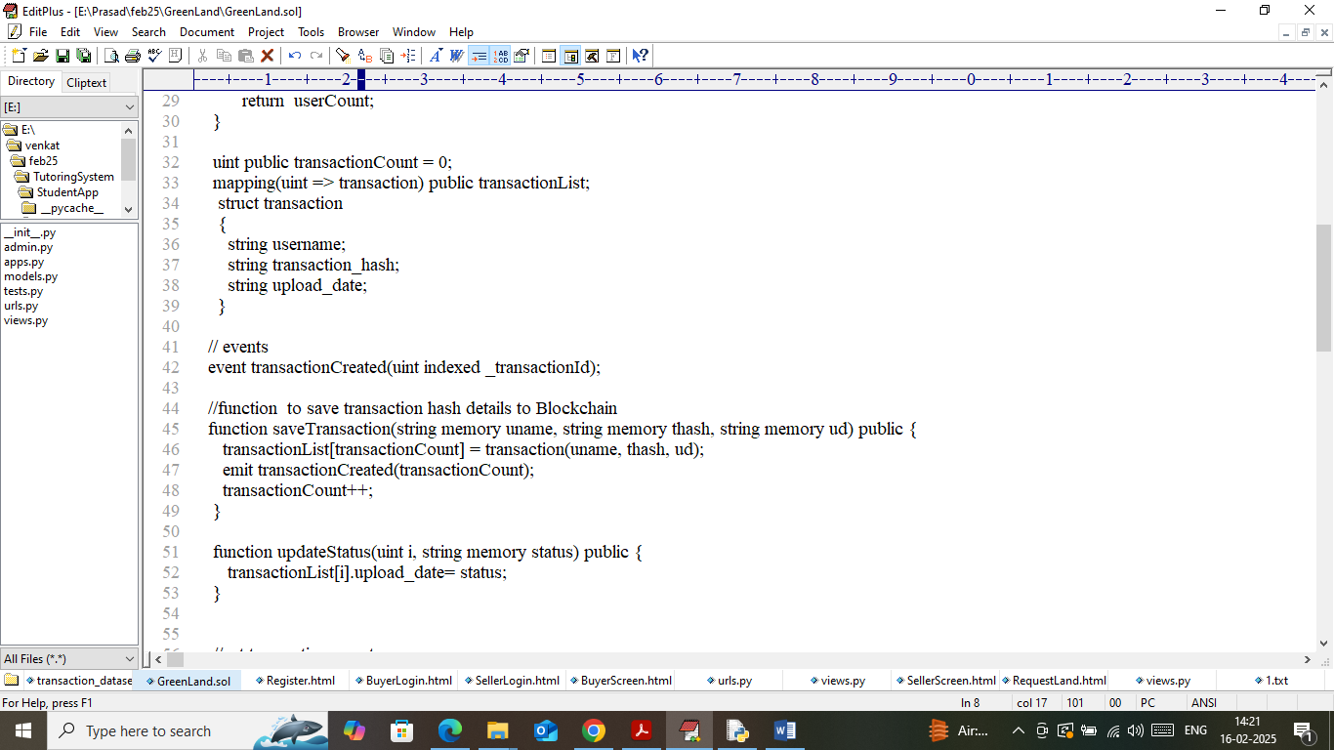

In above smart contract screen we have designed function to manage buyer, seller and IPFS storage hashcode details. Now we need to deployed above contract in Blockchain Ethereum using below steps

1. First go inside ‘hello-eth/node-modules/bin’ folder and then look and double click on ‘runBlockchain.bat’ file to get below screen
2. 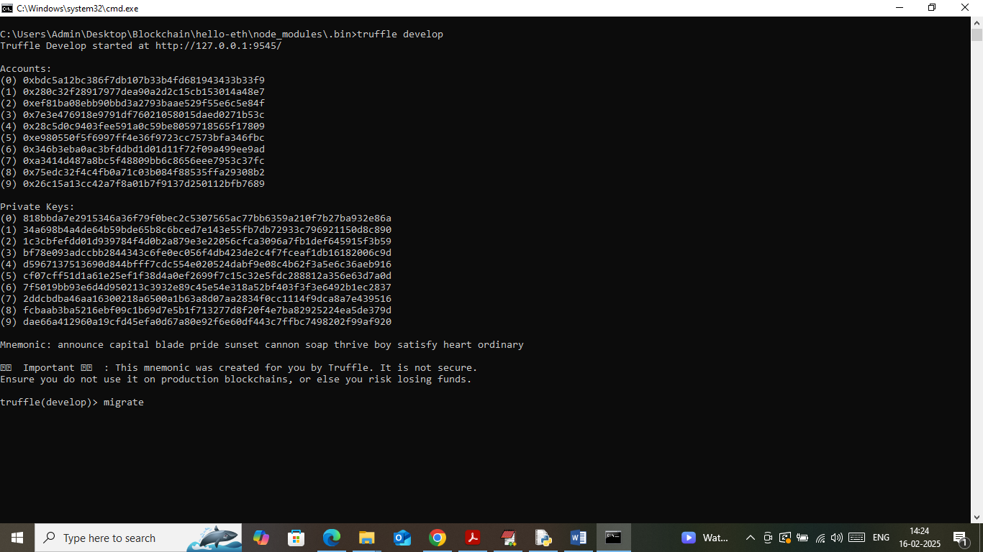
3. In above screen Ethereum started with default accounts and private keys and now type command as ‘migrate’ and then press enter key to get below page
4. 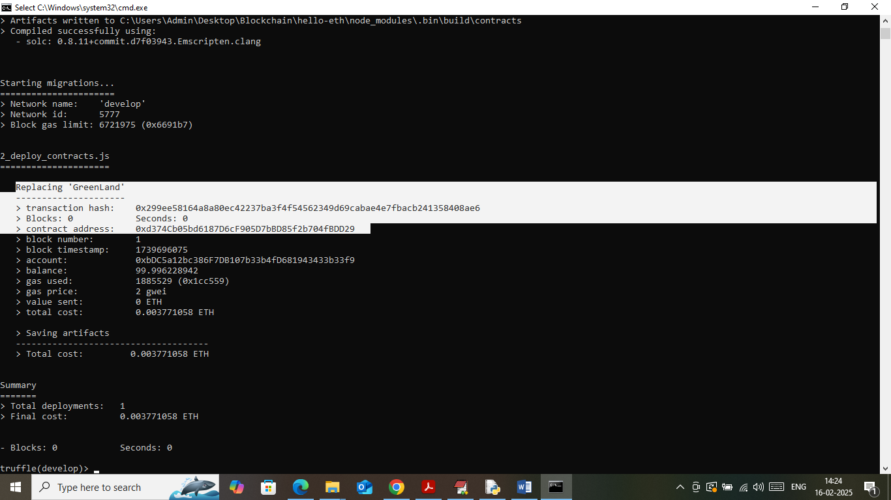
5. In above screen in white colour text can see ‘Greenland’ contract deployed and running successfully and let it run till you execute code. Now copy above contract address showing white text and then paste in python code to call above contract. In below screen showing python code calling above contract using address
6. 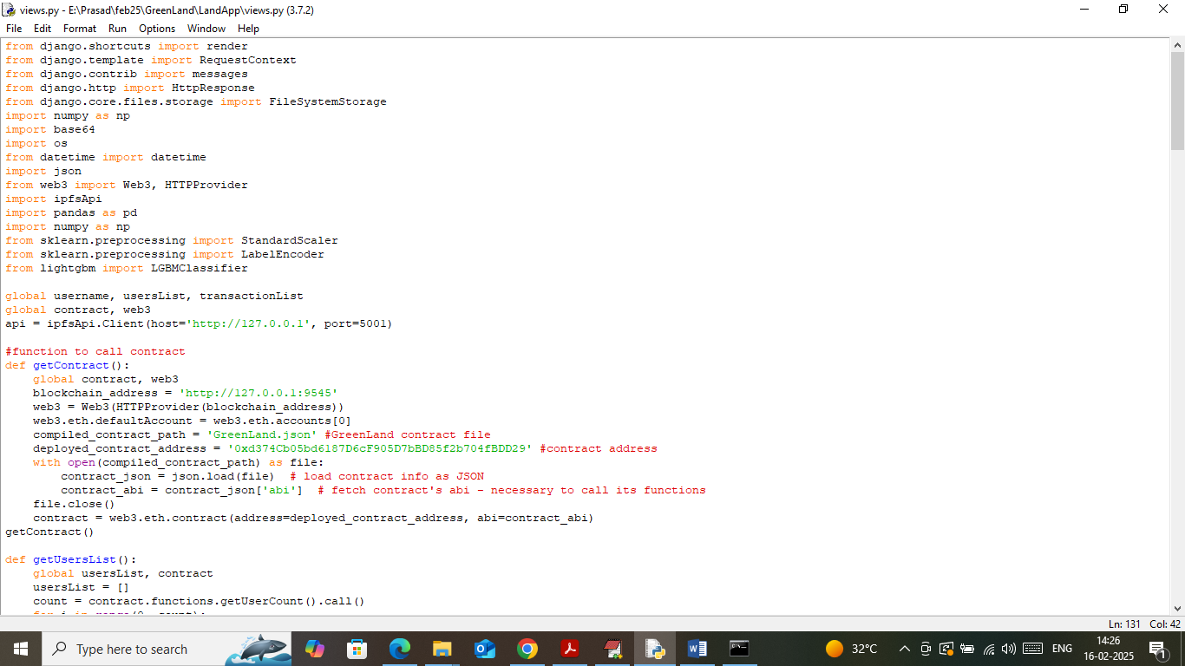
7. In above screen read red colour comments to know about contract calling using address. In above screen Blockchain running successfully and now double click on ‘Start_IPFS.bat’ file to start IPFS server and get below page
8. 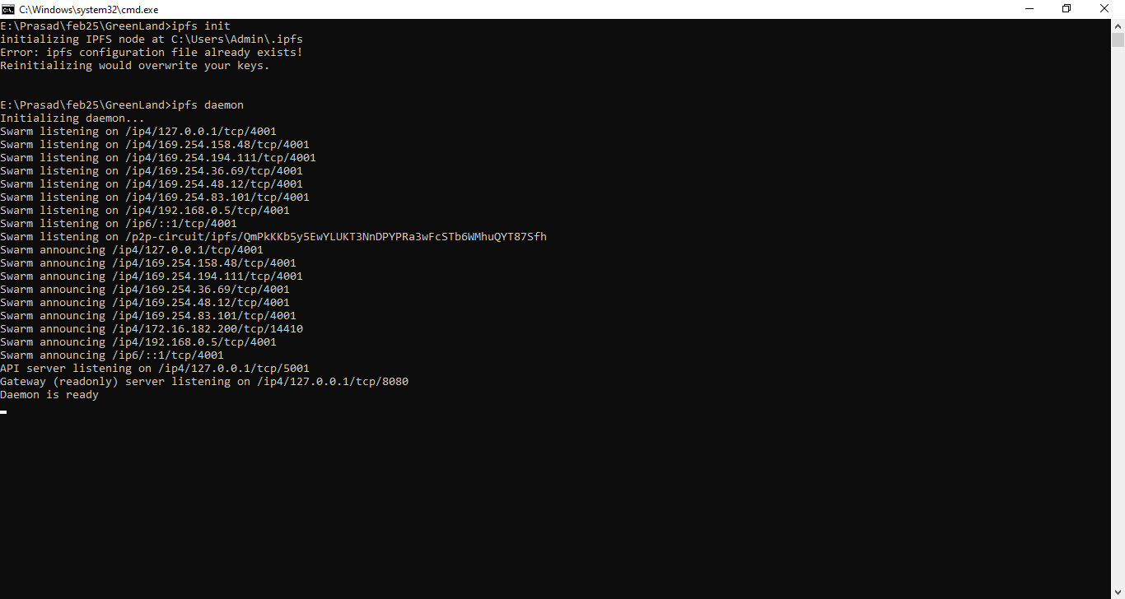
9. In above screen IPFS server started and let it run till you execute code.

In above screen Blockchain and IPFS applications started and now in below screen showing JUPYTER notebook for ML algorithms training and processing and to start JUPYTER double click on ‘runJupyter.bat’ file to get below page

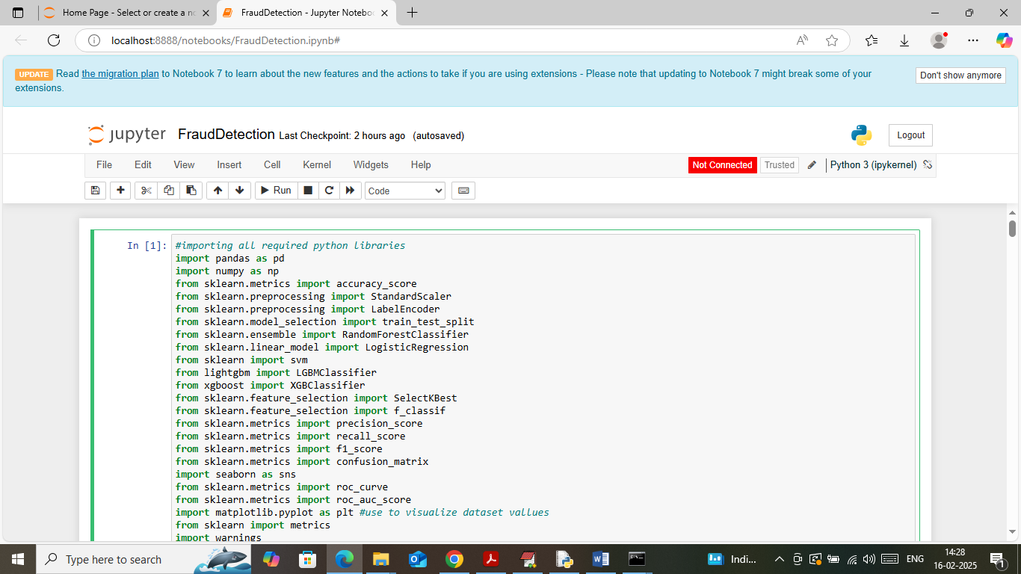

In above JUPYTER screen importing required python classes and packages

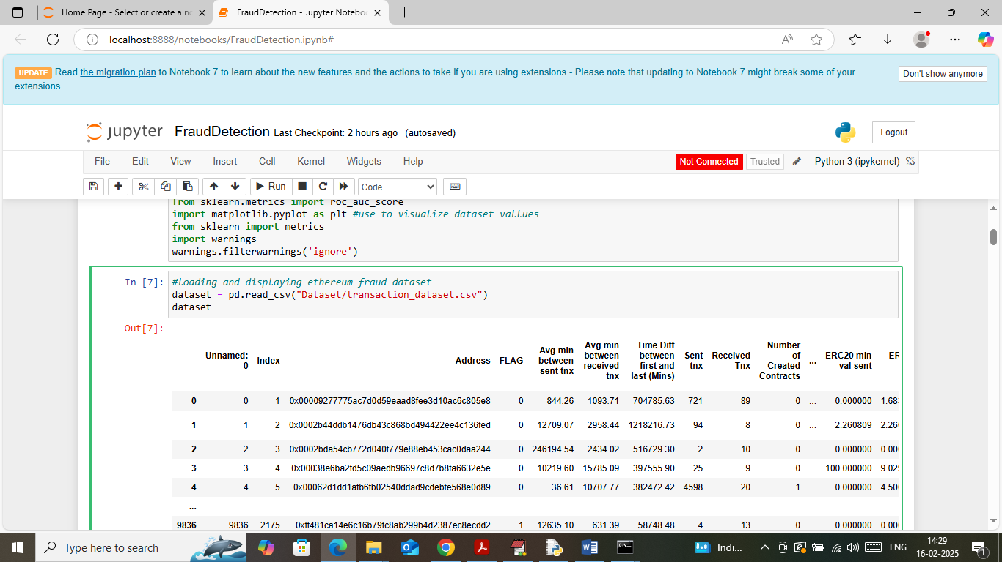

In above screen loading and displaying dataset values

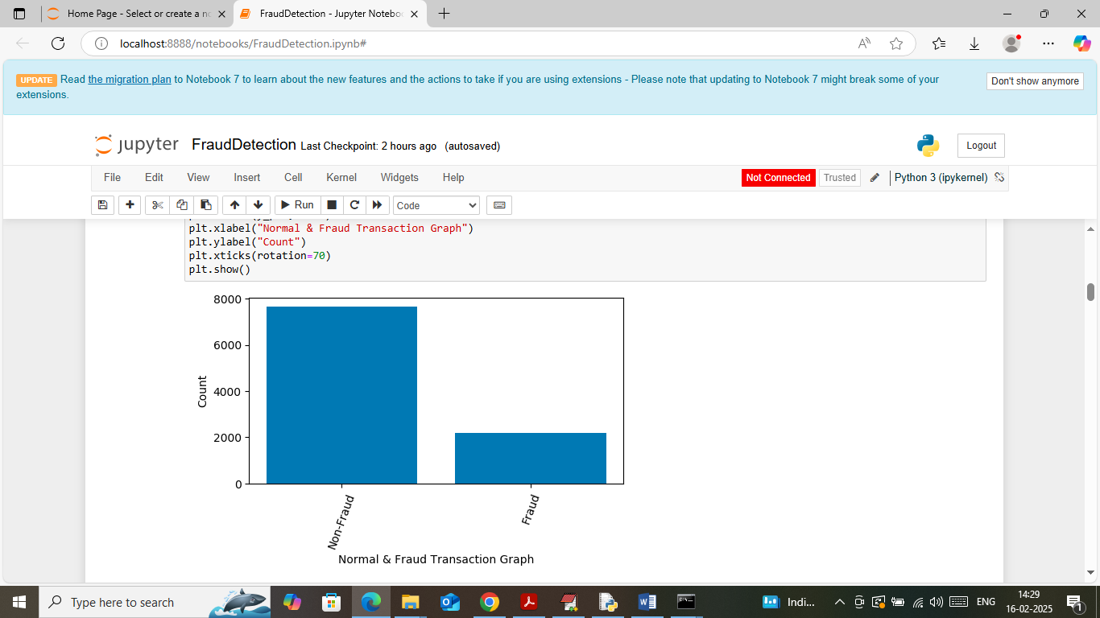

In above screen visualizing ‘Fraud and Non-fraud’ transaction graph from dataset

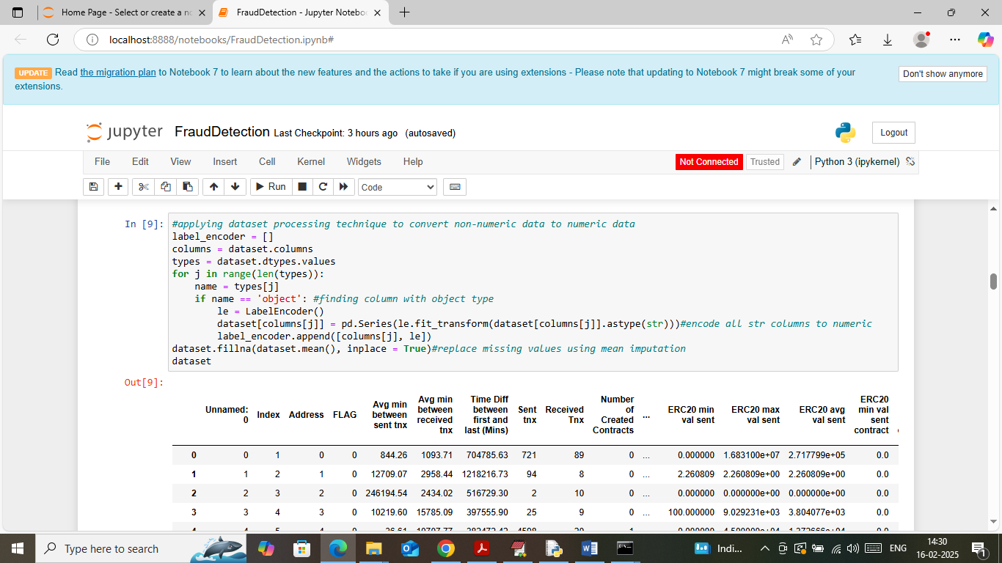

In above screen applying dataset processing technique to convert non-numeric data to numeric data using Label Encoder and then imputing mean function to replace missing values and then can see entire dataset converted to numeric format

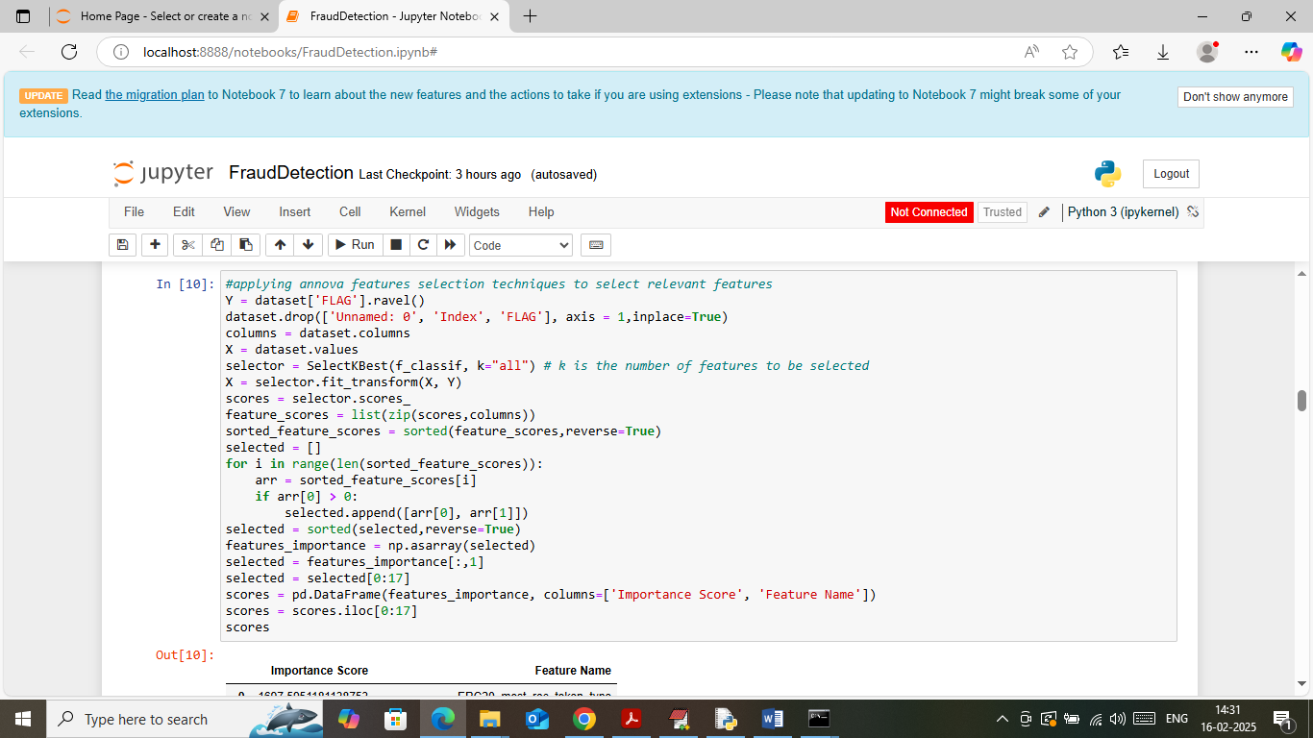

In above screen applying ANOVA features selection algorithm to select relevant features from dataset and then will get below page

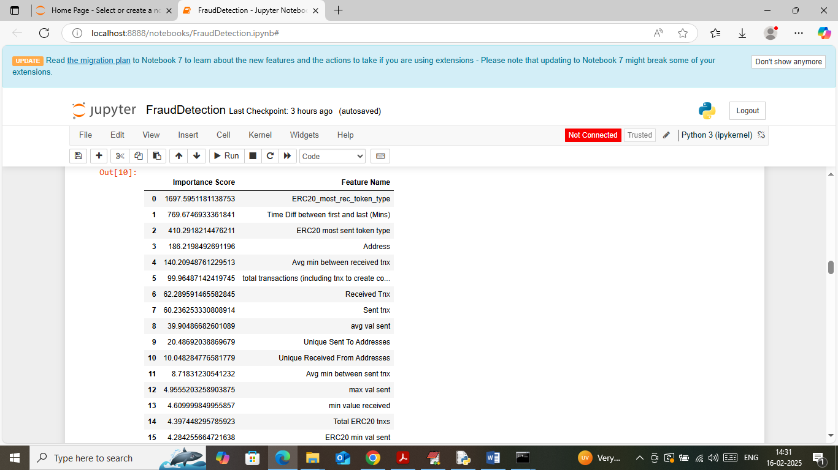

In above screen can see list of selected features along with importance scores

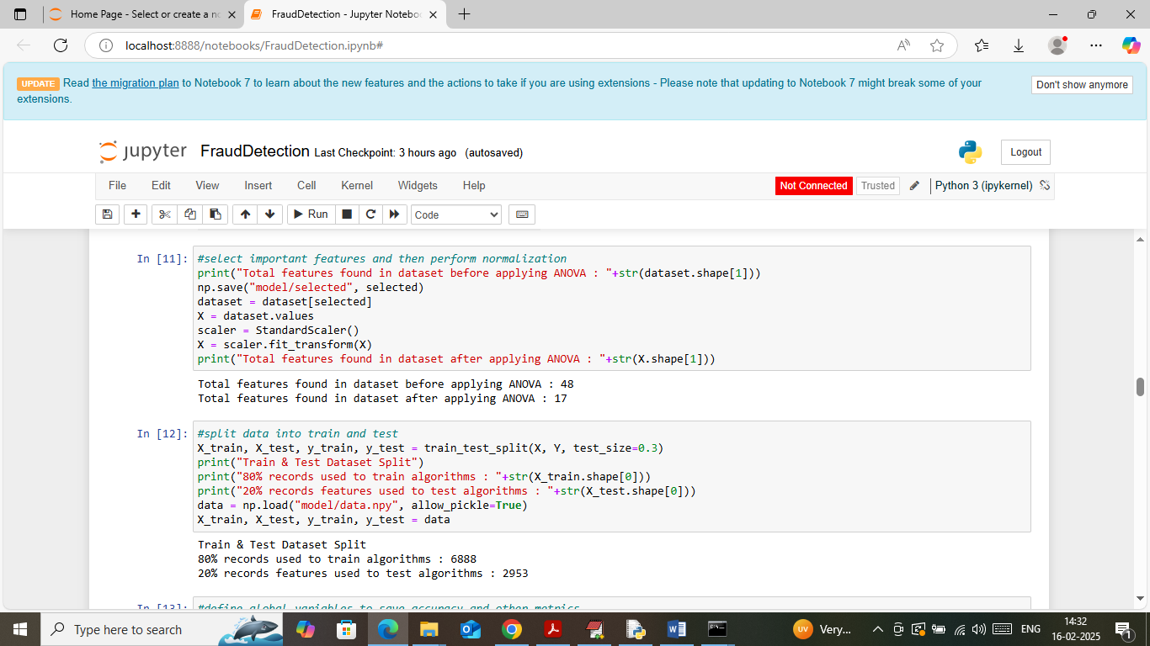

In above screen displaying number of features before and after applying ANOVA algorithm and then displaying train and test data where application using 80% dataset for training and 20% for testing

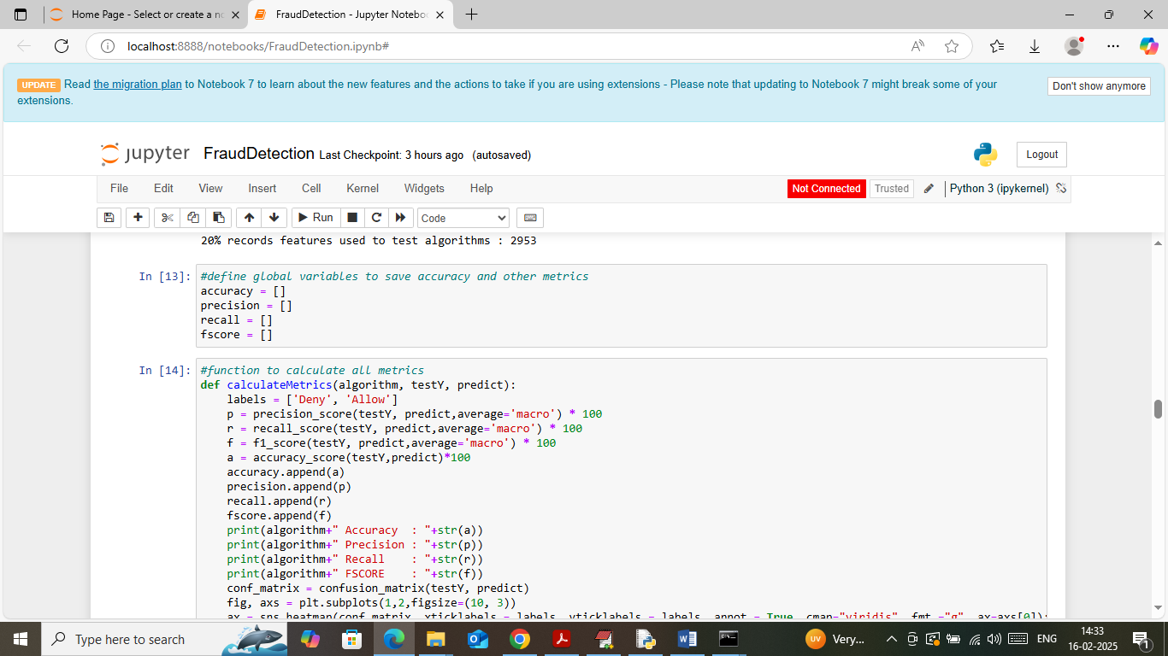

In above screen defining function to calculate accuracy and other metrics

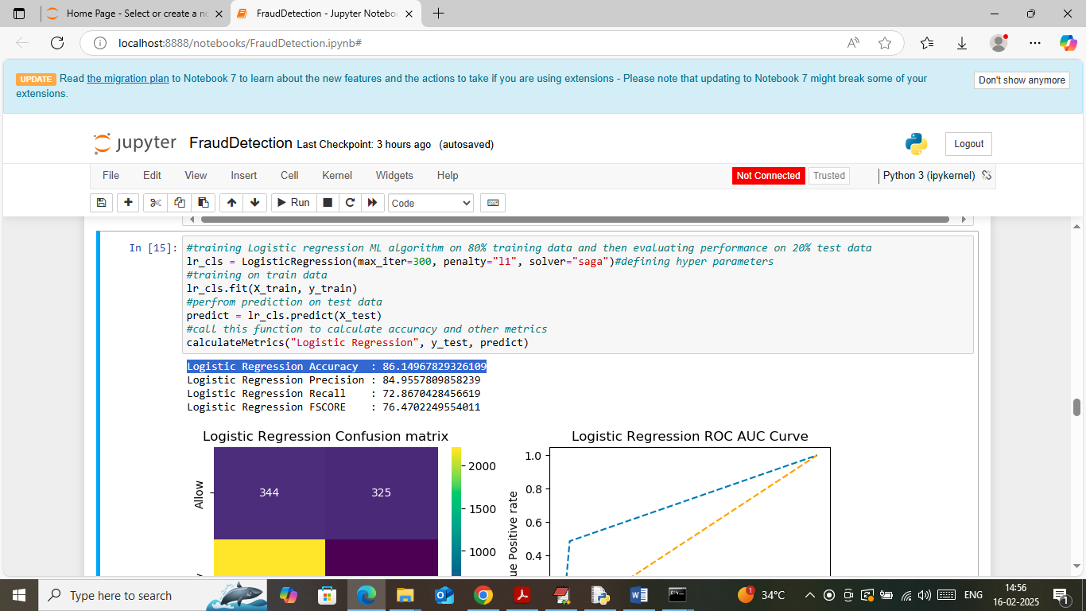

In above screen training logistic regression algorithm on training data and then performing prediction on 20% test data and then logistic regression got 86% accuracy and can see other metrics like precision, recall and FSCORE. Below is the confusion and ROC graph

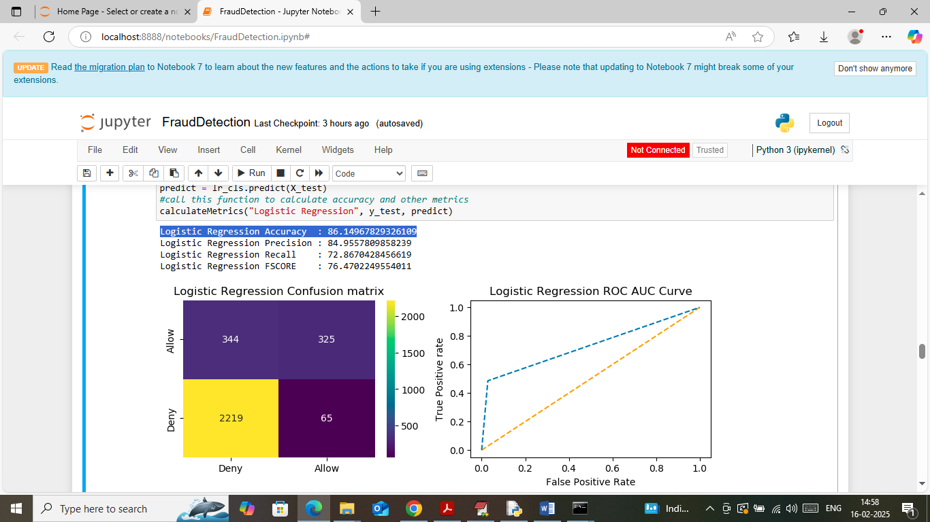

In above confusion matrix graph x-axis represents predicted labels and y-axis represents true labels and then yellow and light blue boxes in diagonal represents correct prediction count and remaining blue boxes represents incorrect prediction count. In above ROC graph x-axis represents False Positive Rate and y-axis represents True Positive rate and if blue line comes on top of orange line then all predictions are correct and if goes below blue line then all predictions are incorrect.

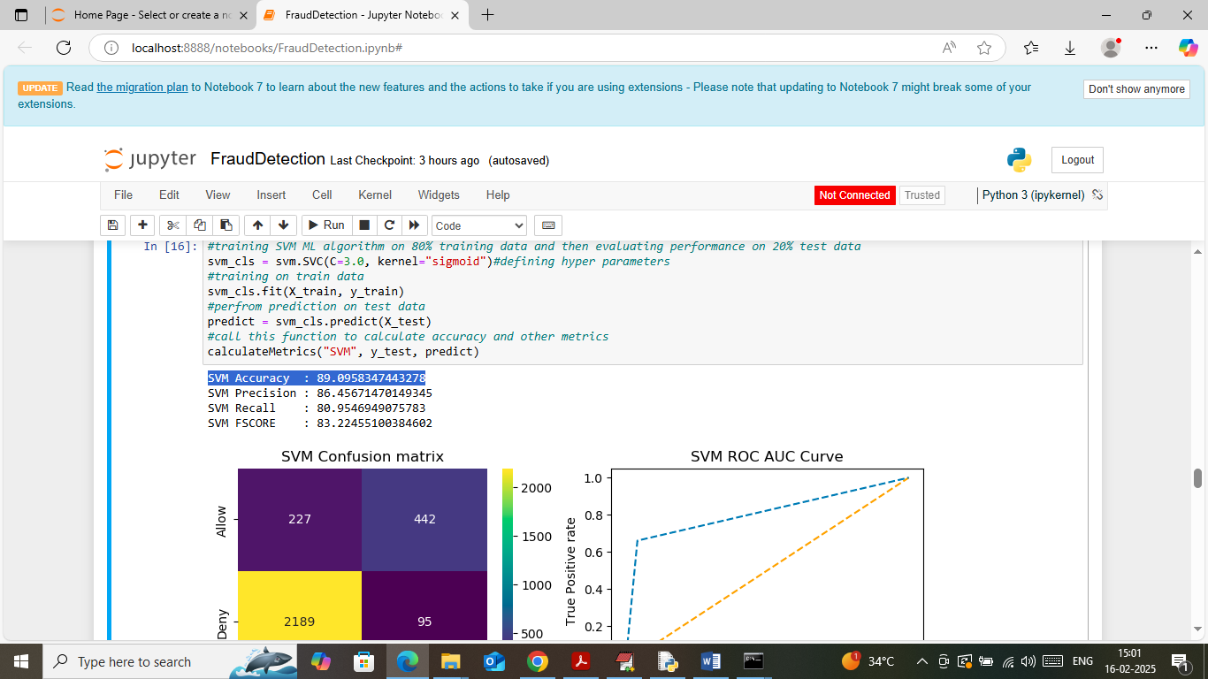

In above screen SVM got 989% accuracy and can see other metrics also

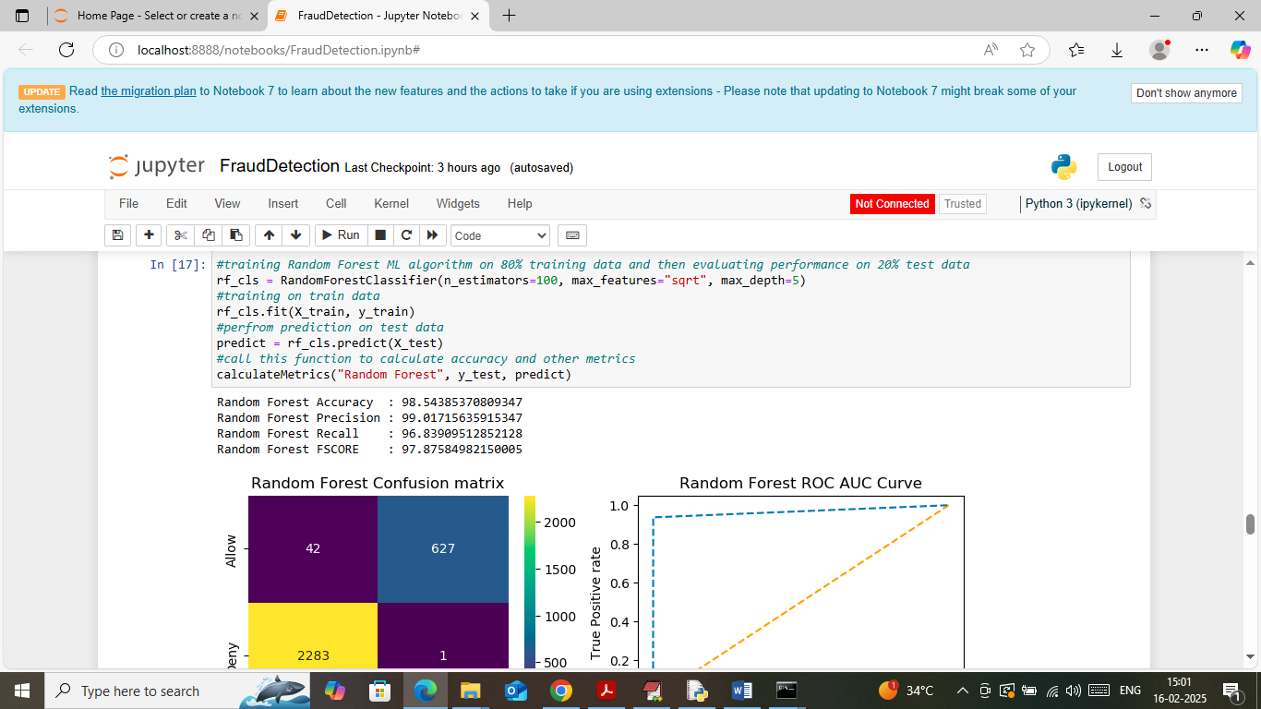

In above screen Random Forest got 98% accuracy

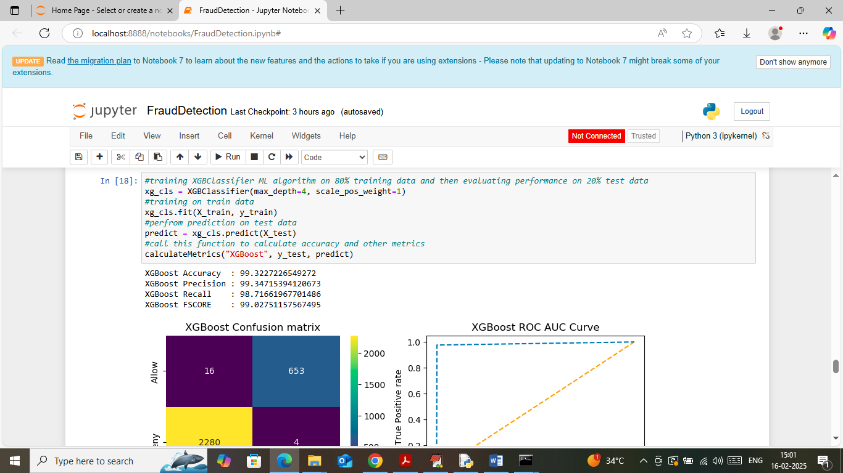

In above screen XGBOOST got 99.32% accuracy

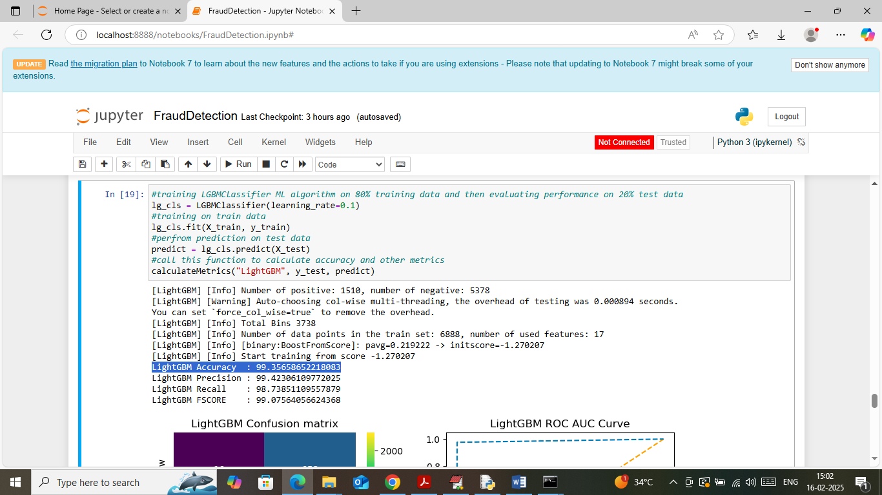

In above screen LIGHTGBM got 99.35% accuracy

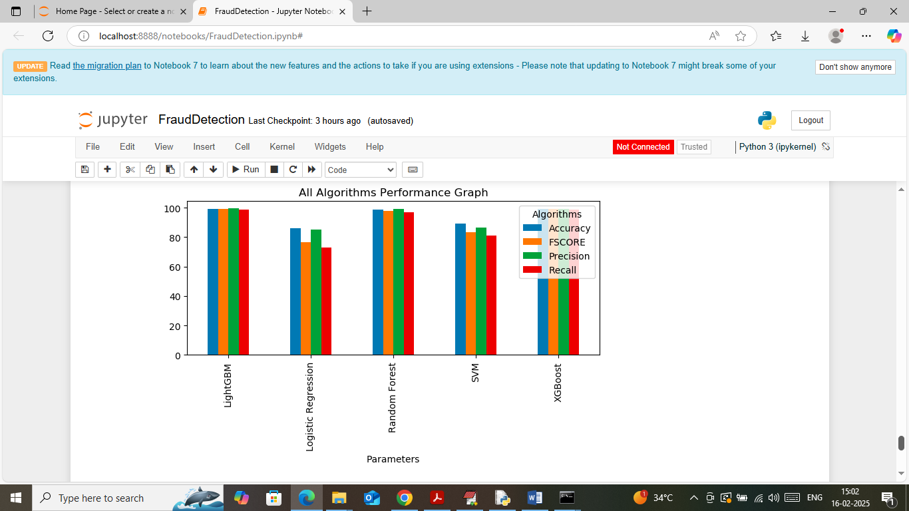

In above screen visualizing comparison graph between all algorithms where x-axis represents algorithm names and y-axis represents accuracy and other metrics in different colour bars.

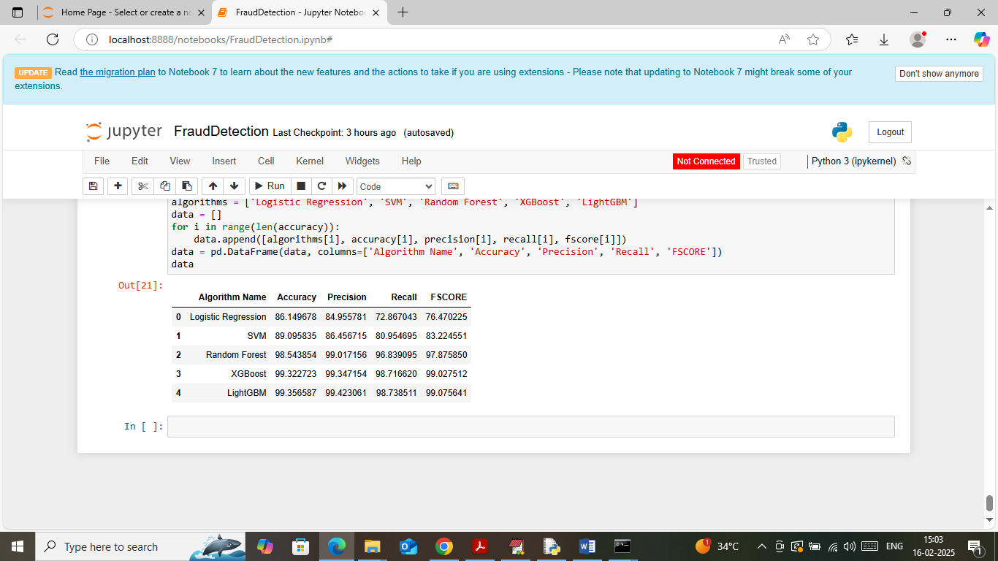

In above screen can see all algorithms performance in tabular format where LIGHTGBM got high accuracy.

SO ABOVE ARE THE ML algorithms output.

WEB SCREEN OUTPUT

In web we have designed buyer and seller modules along with predictions and below are the each module description

1. New User Sign up: using this module buyer and seller can sign up with Blockchain
2. Buyer Login: buyer can authenticate with Blockchain and then issue land request by uploading raw transaction data and then ML algorithm will predict weather transaction data is normal or fraud. Buyer can view transaction status accepted or rejected by seller.
3. Seller Login: seller can login to system and then can view list of buyer request along with ML predicted status as Normal or Fraud. Based on ML prediction seller can accept or reject buyer request.

To run web modules double click on ‘runWebServer.bat’ file to get below page

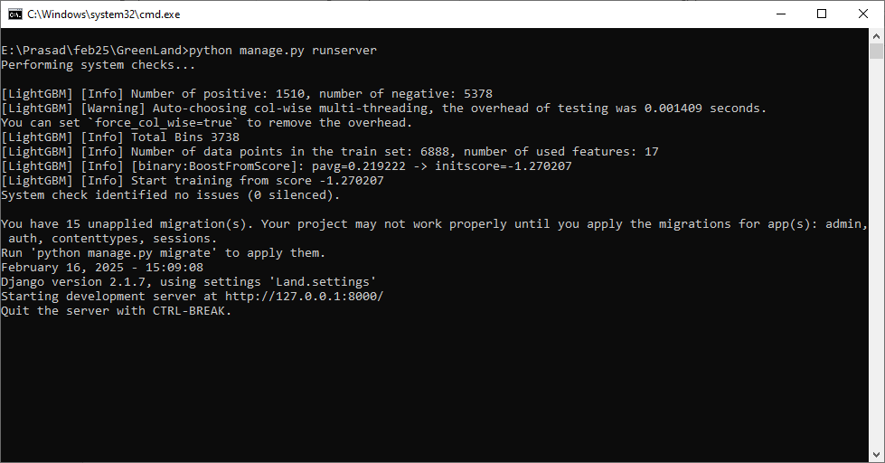

In above screen python web server started and now open browser and enter URL as <http://127.0.0.1:8000/index.html> and then press enter key to get below page

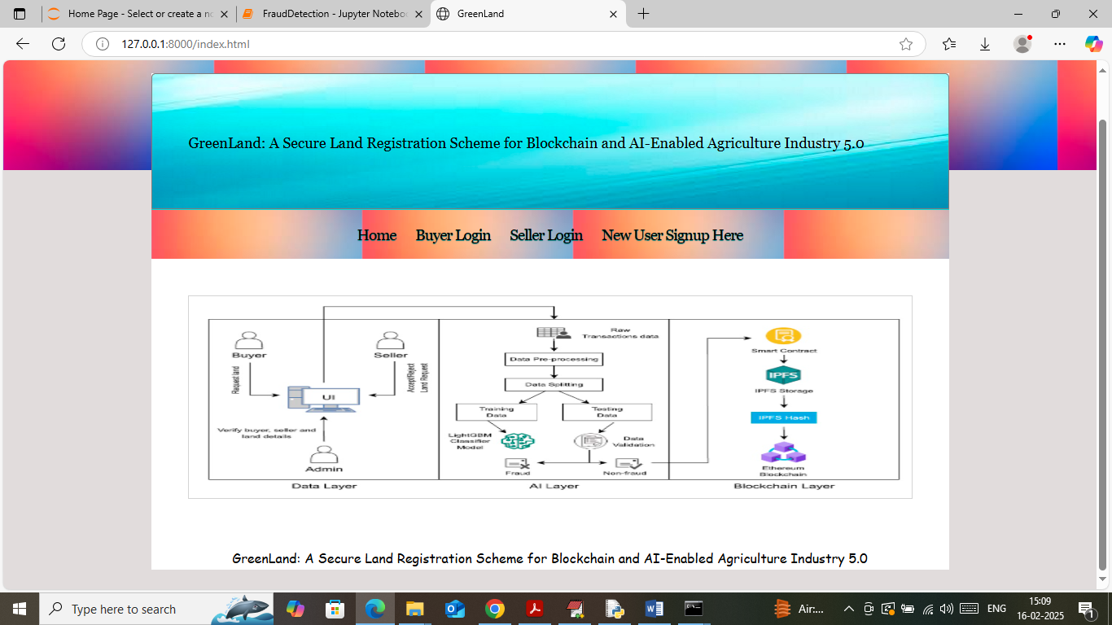

In above screen click on ‘New User Sign up’ link to get below page

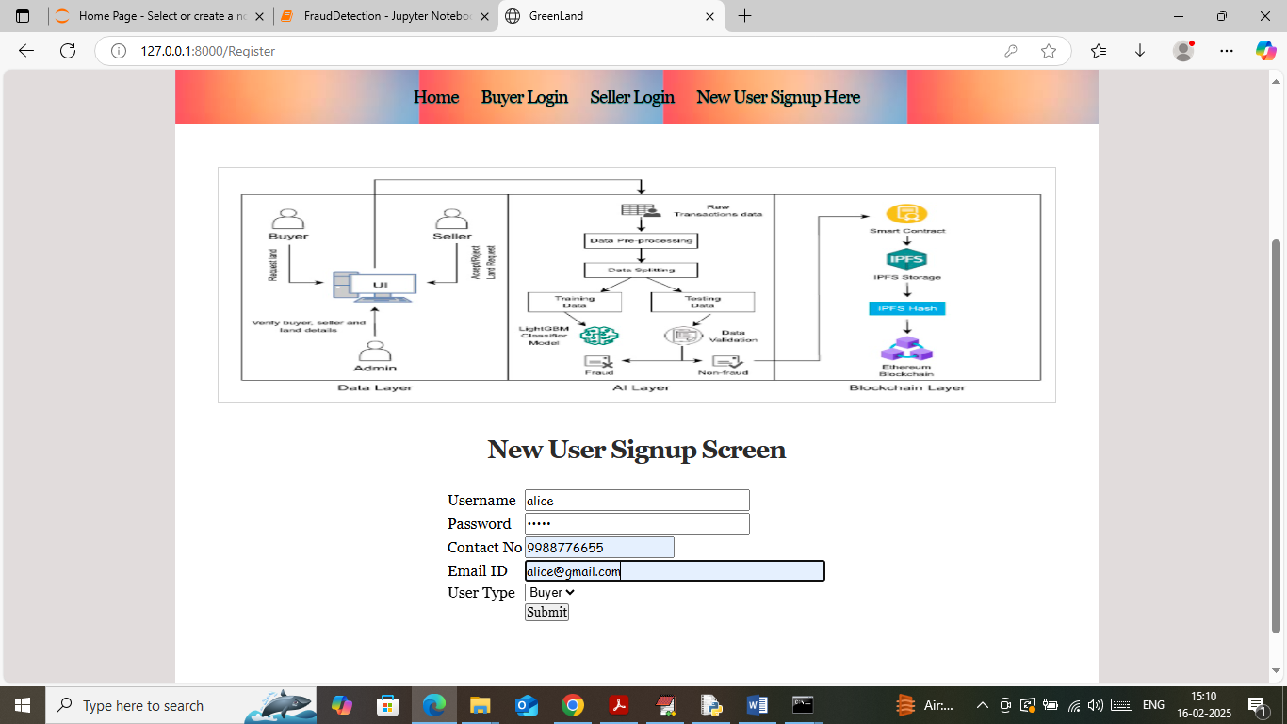

In above screen buyer is getting sign up with the Blockchain and then press button to get below page

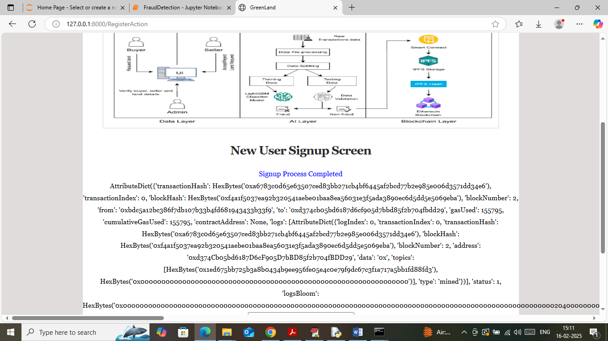

In above screen sign up completed and in next lines I am displaying entire log obtained from Blockchain after storage. In above log can see details like transaction no, hash code, block no and many other details. Similarly you can sign up seller also

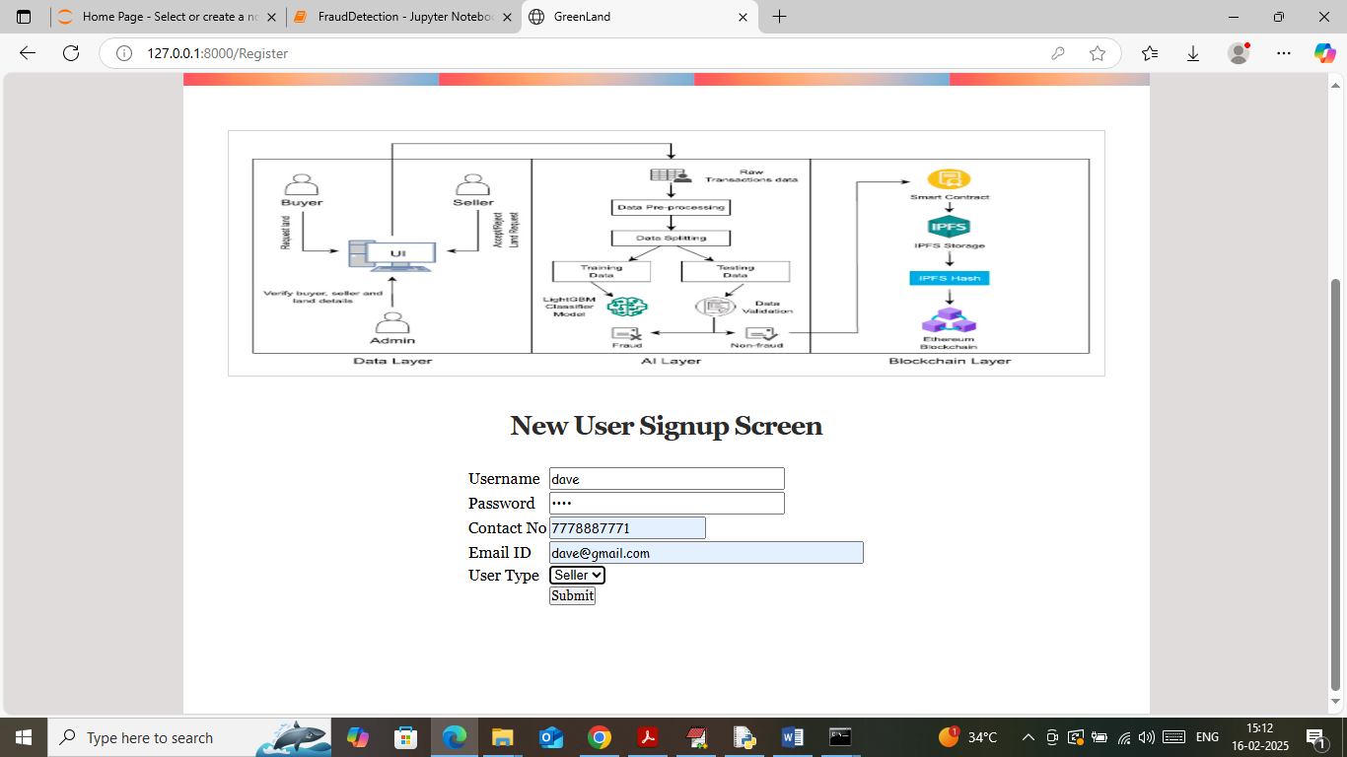

In above screen seller is getting sign up and then press button to get below page

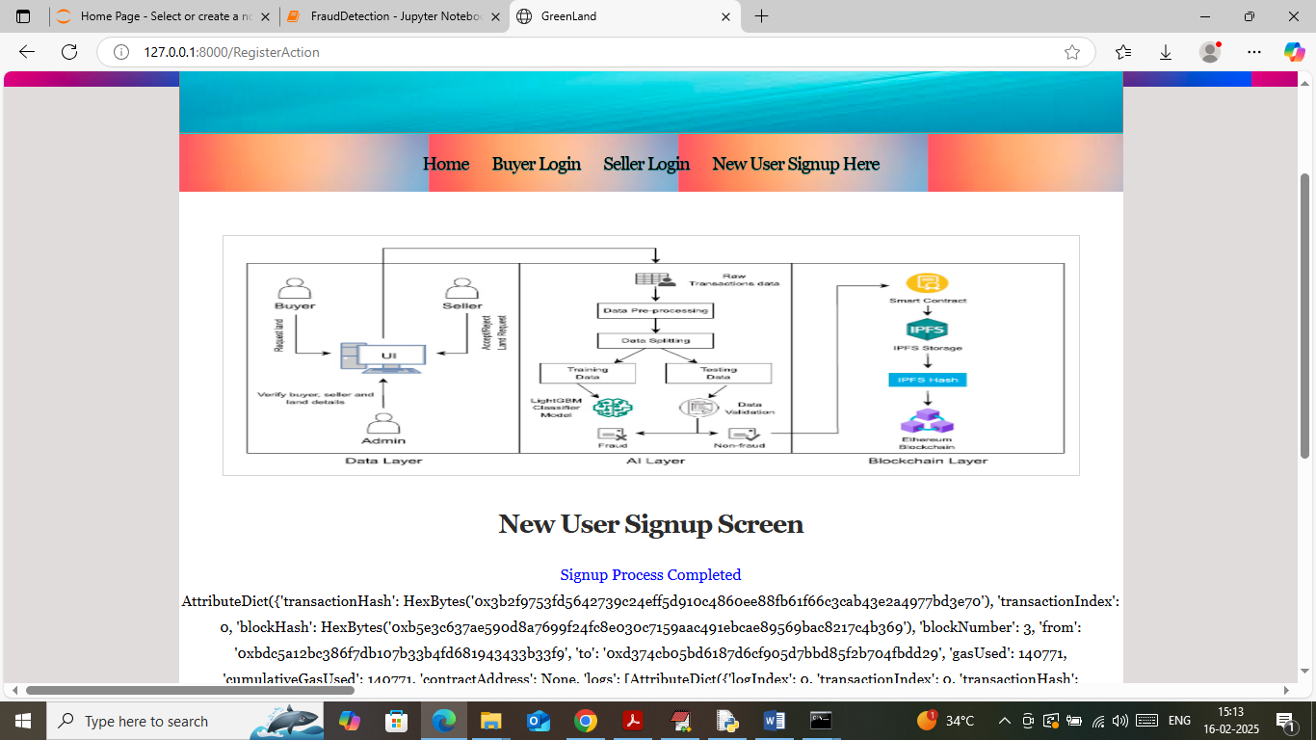

In above screen seller sign up also completed and now click on ‘Buyer Login’ link to get below page

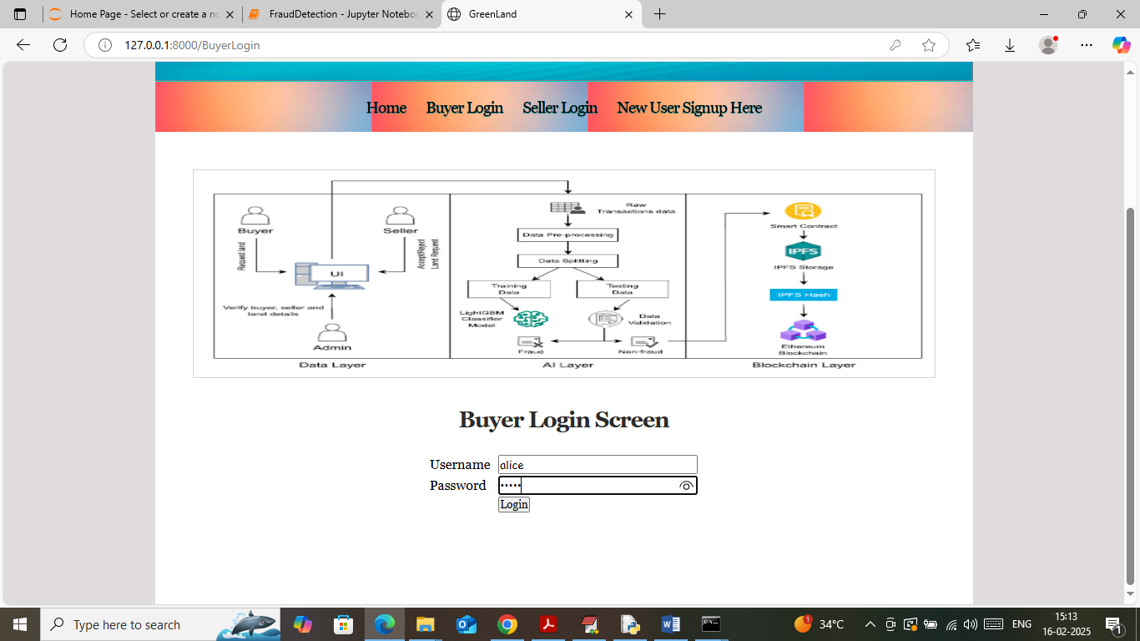

In above screen buyer is login and after login will get below page

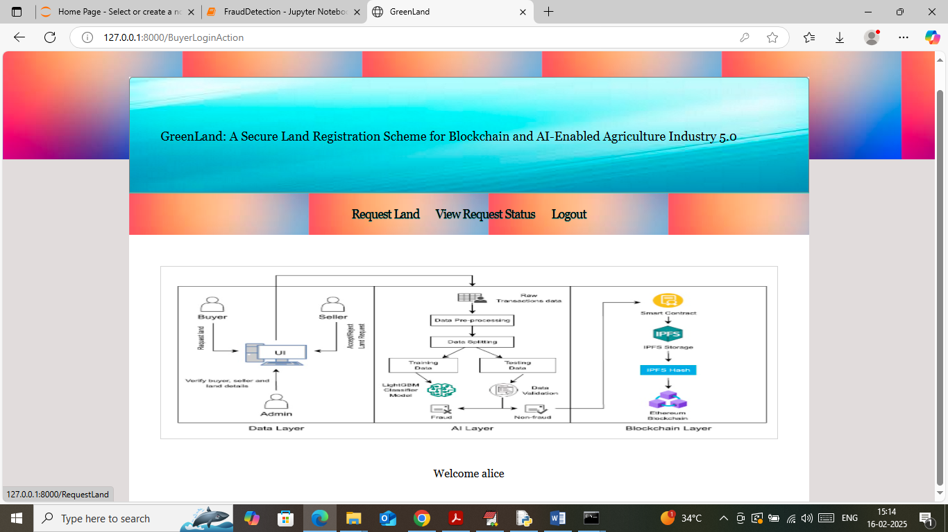

In above screen buyer can click on ‘Request Land’ link to get below page

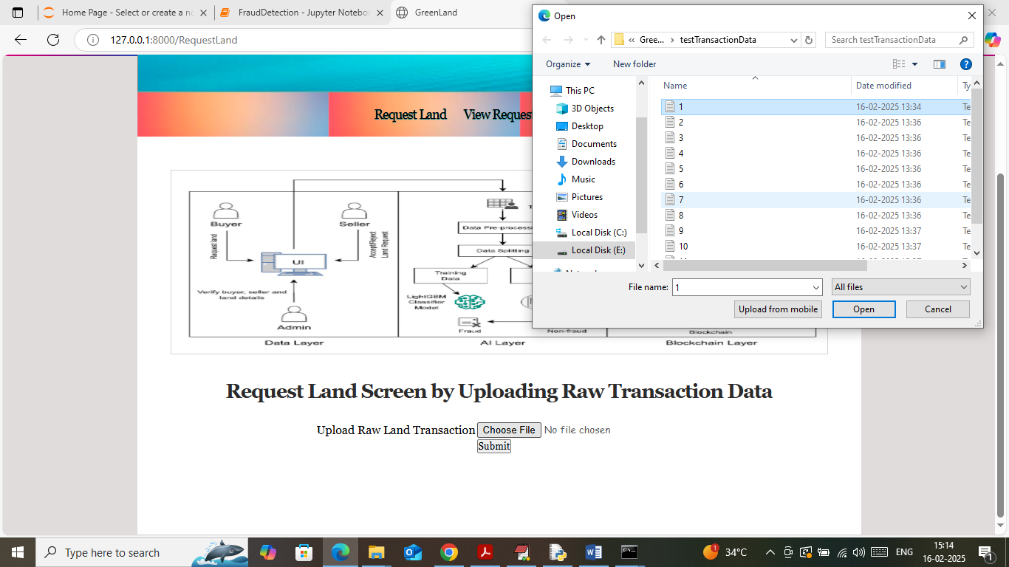

In above screen selecting and uploading transaction data and then click on ‘Open and submit’ button to save data in IPFS and Blockchain and ML will also predict weather transaction fraud or non-fraud and then will predict below output

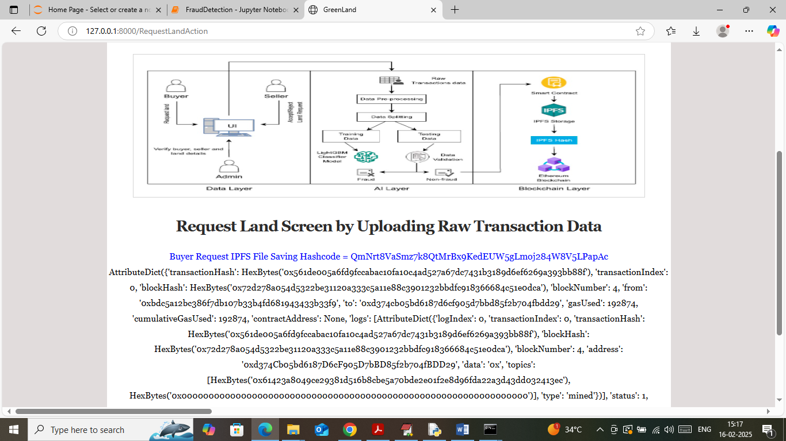

In above screen blue text can see transaction output status and similarly you can upload as many transactions as you want. Now logout and login as seller to accept or reject request

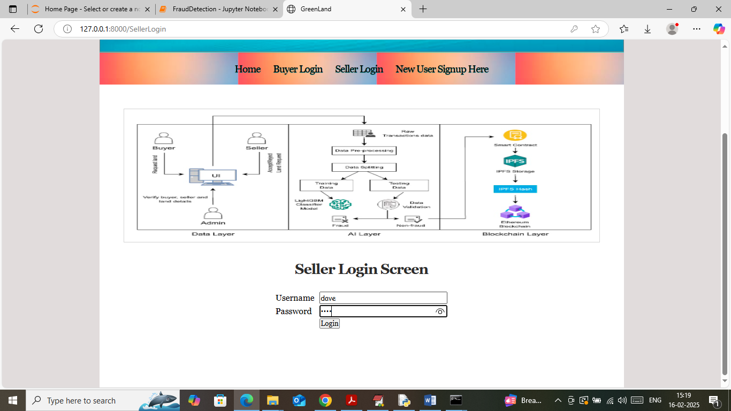

In above screen seller is login and after login will get below page

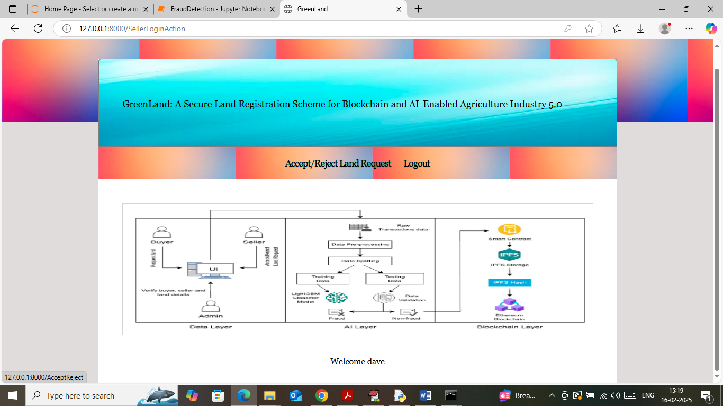

In above screen seller can click on ‘Accept/Reject Land Request’ link to get below page

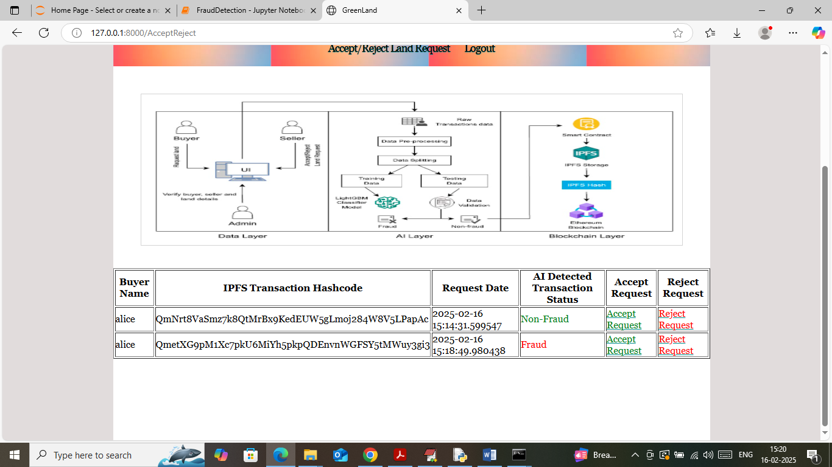

In above screen seller can view list of land request with details like buyer name, IPFS storage hashcode of raw transaction and then can ML predicted status and then Seller can click on either accept or reject link to get below page

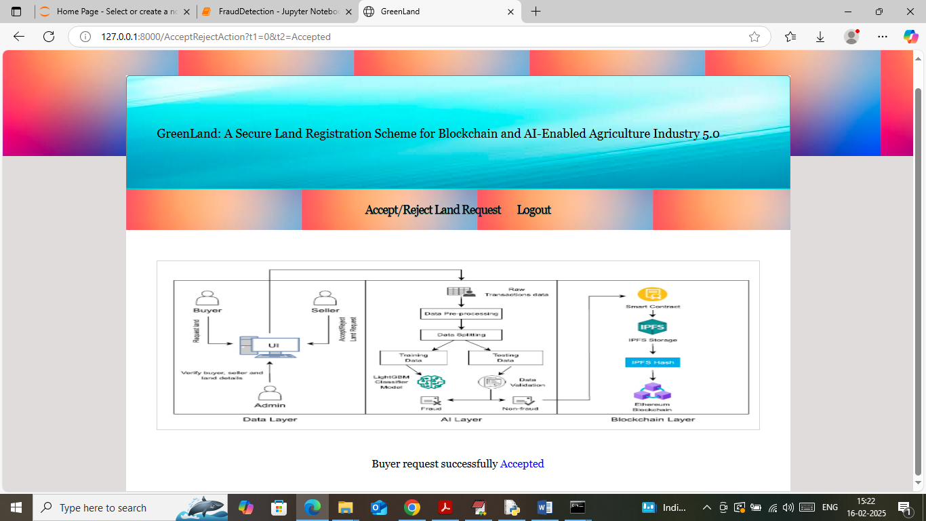

In above screen seller accepted one request and now logout and login as buyer to view status

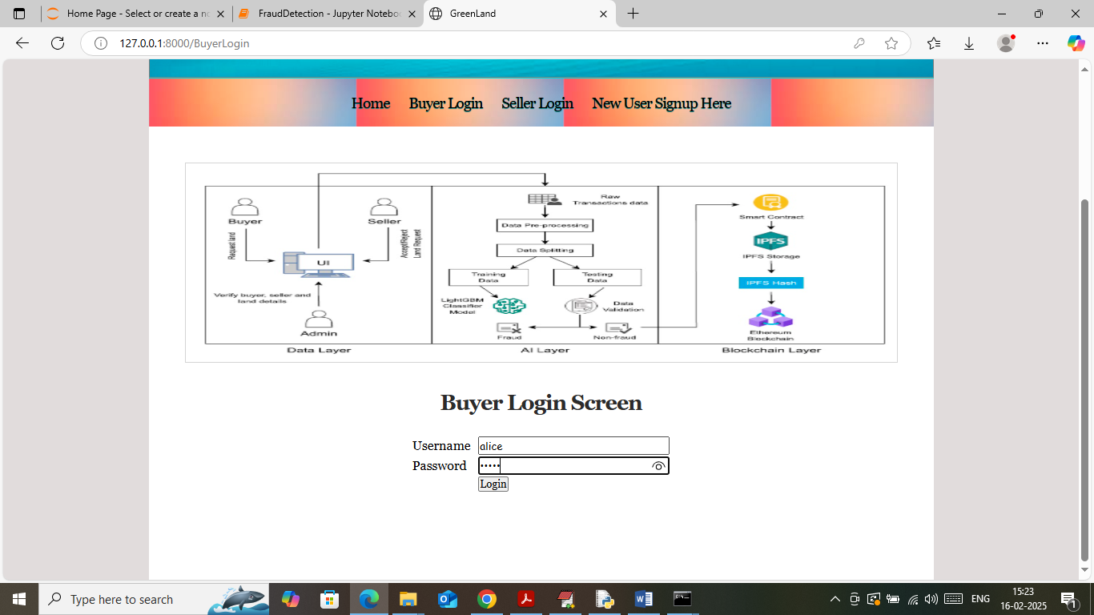

In above screen buyer is login and then will get below page

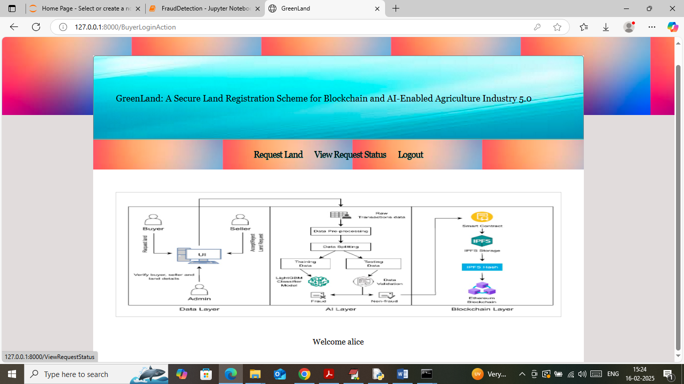

In above screen buyer can click on ‘View Request Status’ link to get below page

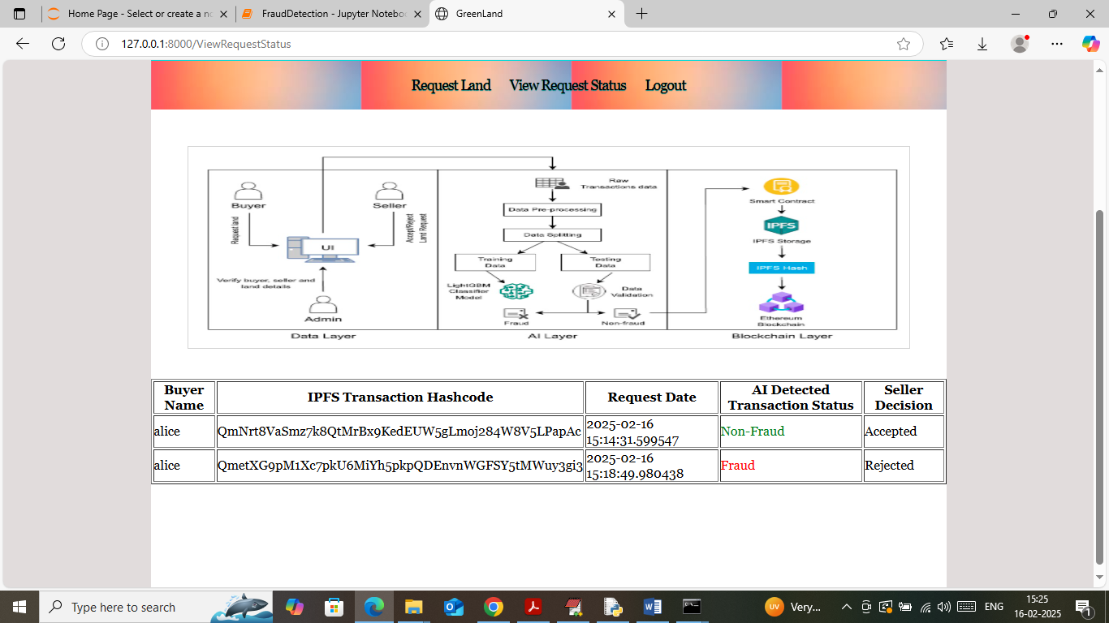

In above screen buyer can view all transaction raw data hashcode and then can ML predicted output along with seller decision as “Accepted or Rejected’.

So in above screens we have shown output of all possible modules